SEX-LINKED GENETICS

In humans the first 22 chromosomes are called autosomal chromosomes and are responsible for many of the inherited traits such as eye colour, skin pigment and hair colour.

The 23rd pair of chromosomes, the sex chromosomes, look different and carry different genes. The sex chromosomes are not necessarily identical in their appearance and gene content.

The X chromosome carries genes that affect body structures and functions. These characteristics are called X-linked because in most cases there is no corresponding allele on the Y chromosome. Genes carried only on the Y chromosome are called Y-linked.

Generally, the characteristics carried on X or Y chromosome are called sex-linked.

Colour blindness is a clear example of X-linked inheritance. Normal colour vision is determined
by the presence of the dominant gene, which can be called B rather than C so that it is not mixed up with a lower case c. Colour blindness results from the recessive gene b.

e.g. A female, with her two X chromosomes, can be either homozygous X^{B}X^{B} (called
normal) or heterozygous X^{B}X^{b} (called a carrier) and still have normal colour vision.

She will be colour blind only if she has two recessive alleles, X^{b}X^{b}.

A male with only one X chromosome displays the trait that the chromosome carries.

i.e. X^{B}Y is normal. X^{b}Y is colour blind.

There are a number of conditions that are X-linked, including types of haemophilia, diabetes and
muscular dystrophy.

The table below can be used to determine if a characteristic is X-linked recessive or dominant in a pedigree.

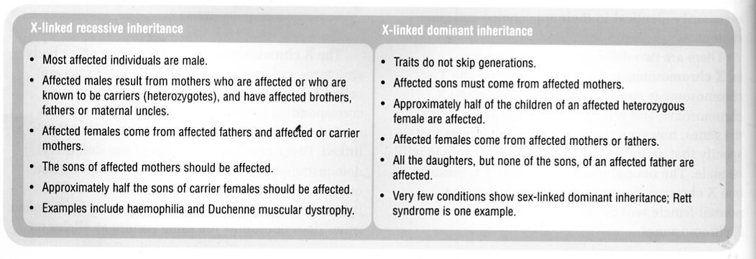

Example

A normal male and a heterozygous (carrier) mother for colour blindness have children together. What is the probability that a boy born to the couple will have colour blindness?

 | X^{B} | Y
X^{B} | X^{B} X^{B} | X^{B} Y
X^{b} | X^{B} X^{b} | X^{b} Y
X^{B}Y x X^{B}X^{b}

F1 genotypes X^{B} X^{B} X^{B} X^{b} X^{B} Y X^{b} Y

phenotypes normal carrier normal colour blind
female female male male

Hence 50 % of the males will be colour blind.

